SW 6 - Three-Out-Of-Four

Jonathan Schwartz

Section 003L

TA: Connor Rickermann

Date submitted: 5/3/2021

**Theory**

Sequential logic is a topic which covers the processing of a sequence of data, including the primer sequence that needs to be detected to start an operation on a datastream. The circuits centered on sequential logic will have “flip-flops” in them in order to store the ‘n’ (for an ‘n-1’-length primer sequence) most recent bits so that the detector can return if a sequence has been reached by ‘looking back’ at the stored data.

The first step is to devise a state diagram which can help make a roadmap for the different steps that determine whether a primer sequence has been achieved. For example, if a primer sequence is 1110, one must first have three consecutive 1’s, followed by a 0 in order for the detector to output a 1, otherwise it will output a 0 (detector will be a 1 if the primer sequence has been achieved). The state diagram below for the case of a primer sequence being 0001 or 1110 has two initial cases, 001 and 110, each of which has only one same-value bit at the end of the string in order to keep uniqueness.

Once the state diagram has been devised, a transition table is to be drawn up based on the state diagram so that the input/output will be structured in a way that is easy to look at and utilize. This transition table will hold the previous states of the flip-flops as well as the immediate subsequent states of them for each option of new input, both a 1 and a 0.

Now that a table of the inputs and outputs is formatted, a K-map is utilized based on the transition table in order to determine the logical equations of the ‘D’ inputs for each flip-flop, as well as the equation of the detector, in a minimized way. The goal of the K-maps is to use the fewest logic gates to achieve the same answer so as to not waste circuit space or add unnecessary materials/delays.

Once the K-maps have been minimized and the equations have been determined for the ‘D’ inputs for each flip-flop, as well as the equation of the detector, it is time to build the circuit based on this information and knowledge of the structure of the sequential logic circuit. Utilizing all of the previous stages that built off each other, the final circuit will be minimized from the K-maps which were determined from the transition table which was based on the state diagram, all the way back at square one.

**State Diagram**

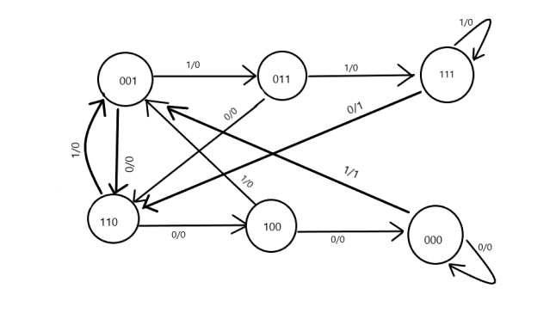

**Transition Table**

| Q2 | Q1 | Q0 | A (Input) | Q2+ | Q1+ | Q0+ | B (Buzzer) |
| --- | --- | --- | --- | --- | --- | --- | --- |
| 0 | 0 | 0 | 0 | 0 | 0 | 0 | 0 |
| 0 | 0 | 0 | 1 | 0 | 0 | 1 | 1 |
| 0 | 0 | 1 | 0 | 1 | 1 | 0 | 0 |
| 0 | 0 | 1 | 1 | 0 | 1 | 1 | 0 |
| 0 | 1 | 0 | 0 | X | X | X | X |
| 0 | 1 | 0 | 1 | X | X | X | X |
| 0 | 1 | 1 | 0 | 1 | 1 | 0 | 0 |
| 0 | 1 | 1 | 1 | 1 | 1 | 1 | 0 |
| 1 | 0 | 0 | 0 | 0 | 0 | 0 | 0 |
| 1 | 0 | 0 | 1 | 0 | 0 | 1 | 0 |
| 1 | 0 | 1 | 0 | X | X | X | X |
| 1 | 0 | 1 | 1 | X | X | X | X |
| 1 | 1 | 0 | 0 | 1 | 0 | 0 | 0 |
| 1 | 1 | 0 | 1 | 0 | 0 | 1 | 0 |
| 1 | 1 | 1 | 0 | 1 | 1 | 0 | 1 |
| 1 | 1 | 1 | 1 | 1 | 1 | 1 | 0 |

**Karnaugh Maps**

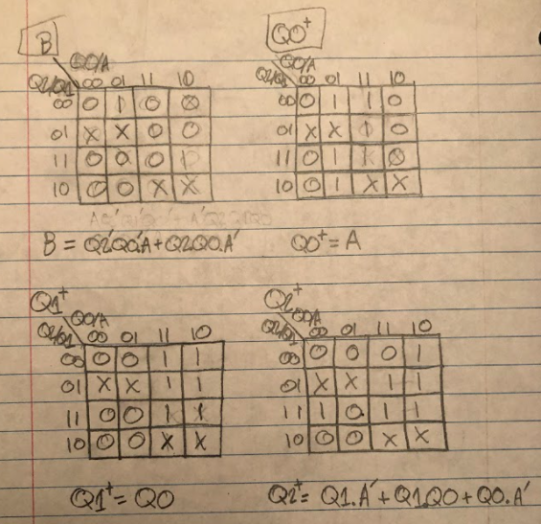

**Circuit**

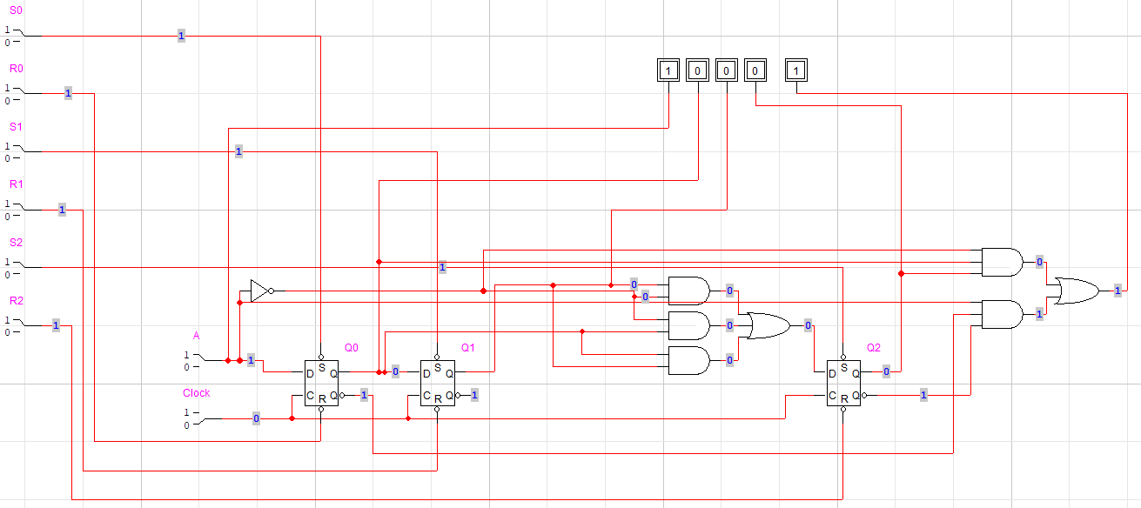

**Testing**

- Include two test cases of different lengths that ultimately result in detection. Record the states from beginning to detection

|  | Case 1 | Case 2 |
| --- | --- | --- |
| Input | 101110001 | 111110010001 |
| Buzzer | 000001001 | 000001000001 |

**Discussion**

I enjoyed how this lab put together so many different topics from throughout the semester because it showed how everything builds off the fundamentals and how it all works together. I also enjoy open-ended projects and application labs because they feel like puzzles to figure out on my own rather than just plugging in knowledge to equations. I think that the lab was very well-formatted, and it wasn’t too difficult to understand, but the only hiccup I had was determining the initial states and how to use different starting bits for 110 and 001 in order to have unique binary strings and have ‘X’ options in my transition table. Overall I thoroughly enjoyed the “do-it-yourself” aspect of this open-ended project.